Fast and Easy Pancakes

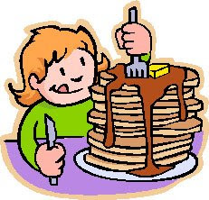
Wet Ingredients
- 1 ¼ cups milk
- 1 Tablespoon white sugar
- 2 eggs
- 1 Tablespoon vanilla extract
- ½ cup vegetable oil

Dry Ingredients
- 1 teaspoon of salt
- 1 ½ cups all-purpose flour
- 1 1/2 teaspoons baking powder

Directions
- Place milk, sugar, eggs, oil and vanilla in a bowl and mix thoroughly with a whisk or rotary beater. (wet ingredients)

- In a separate bowl whisk together salt, flour, and baking soda (dry ingredients).

- Add dry to wet ingredients and mix until almost smooth (a few lumps are okay).

- Heat 1 teaspoon of oil in a frying pan over medium high heat.

- Using a ¼ to ½ measuring cup, pour the batter onto the frying pan.

- Add other ingredients on top of the pancake at this time if you wish.

- Cook until bubbles form all over the top of the pancakes (about 3 to 4 minutes) and then flip to brown the other side (about 2 minutes).

