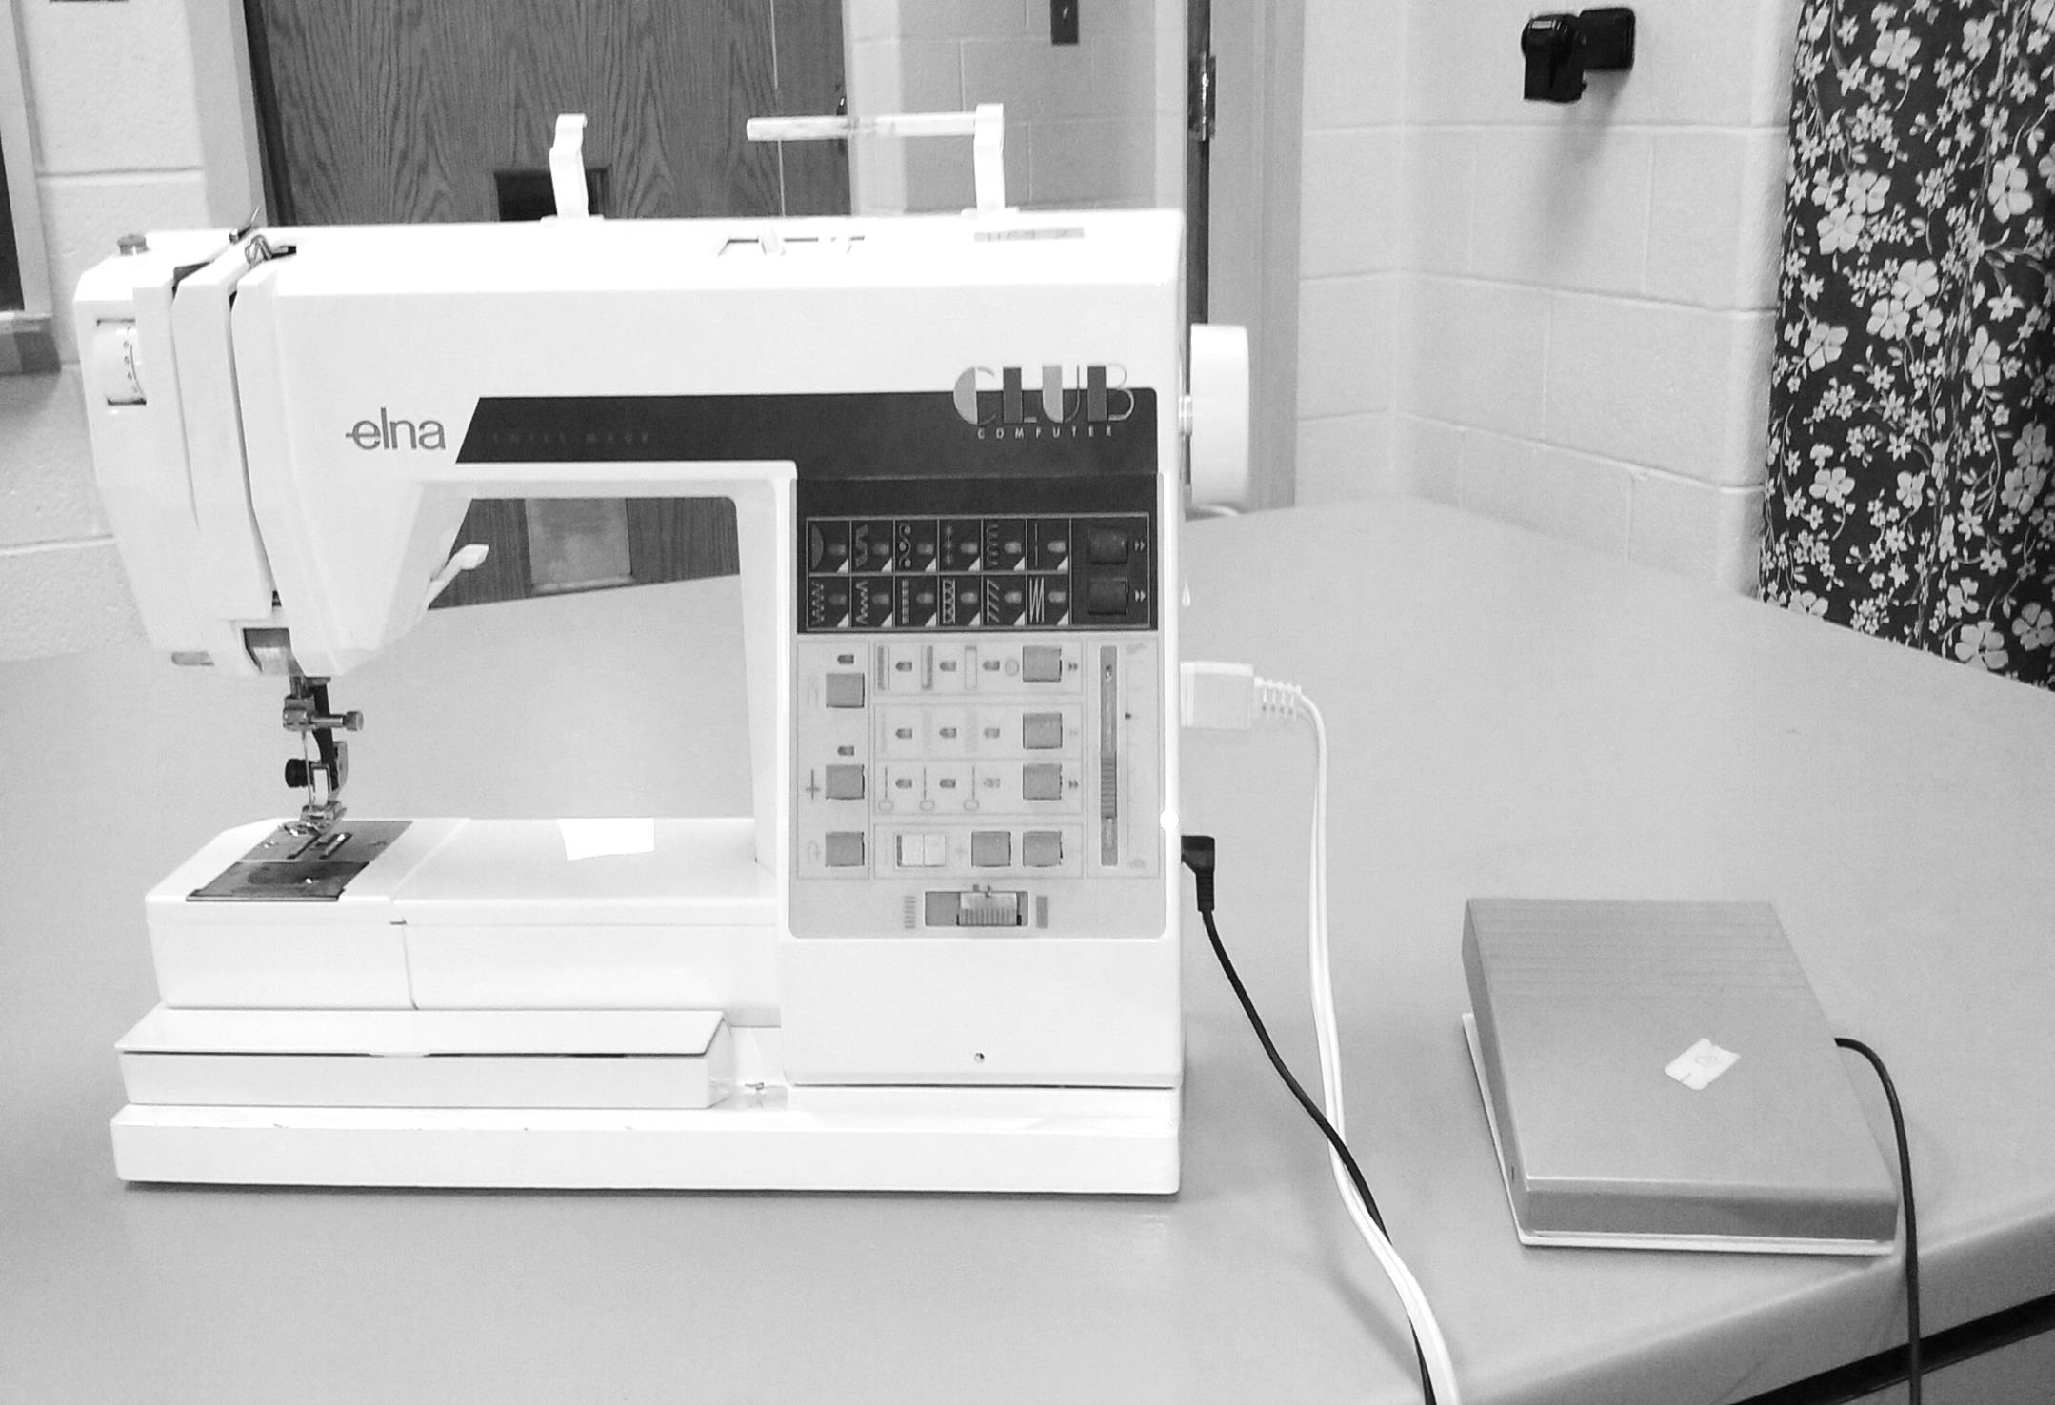

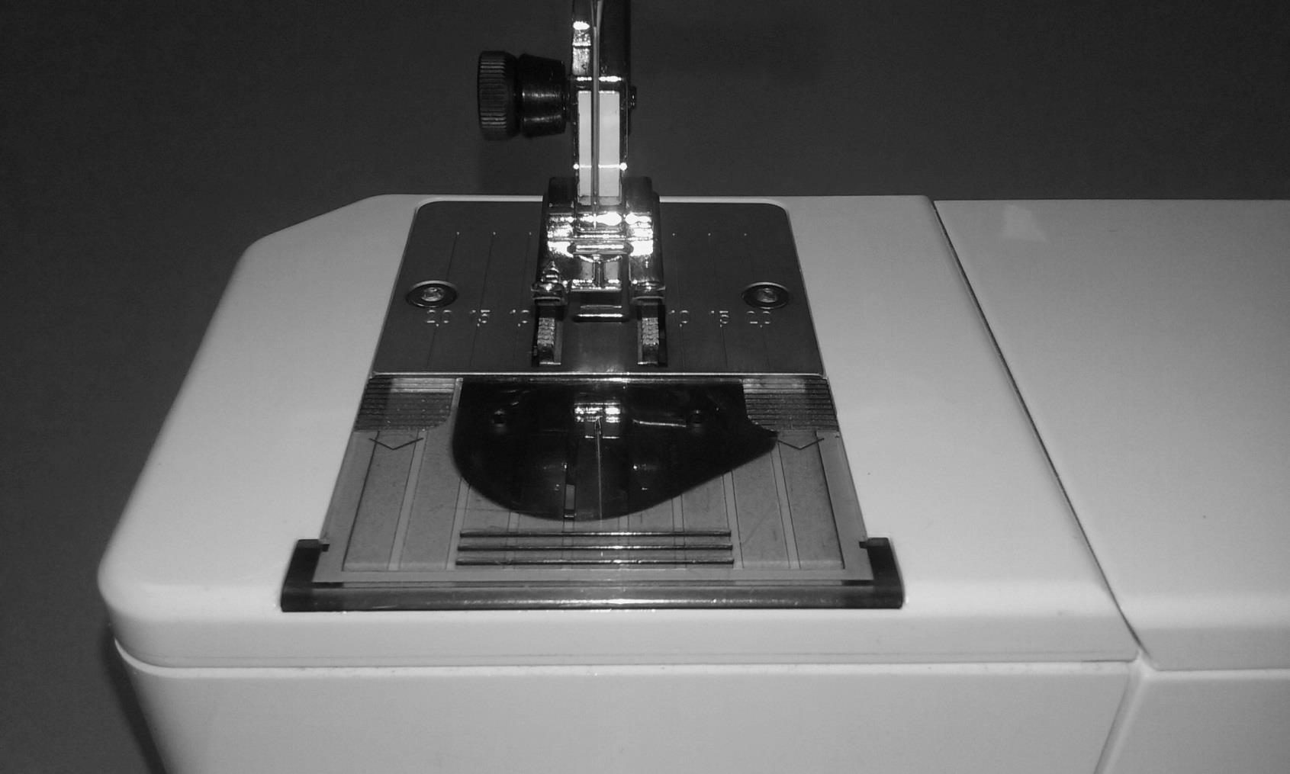

Name: _____________________________

Period: ________________

School: ________________