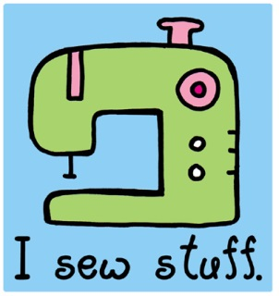
Sewing Machine Notes
Name: ____________________
Date: _____________
Period:____ School: ________
- The Reverse Lever
The reverse lever allows you to stitch in _________________. We use reverse stitches to make our stitches ___________________ at the beginning and end of seams.
- The Stitch Selector
The stitch selector lets you _________________ what kind of ________________ you will be making, such as straight stitches or an embroidery stitch or zig-zag.
- The Stitch Length
The stitch length determines the _____________________ of the stitch.
- The Bobbin Winder
The bobbin winder winds the _________________ from the __________________ onto the bobbin.
- The Spool Pin
The spool pin _____________________ the spool of ______________________.
- The Feed Dogs
The feed dogs are the “_______________________” parts on the throat plate that works with the ______________ foot to _________________________ your fabric through the machine towards the back.
- The Slide Plate
The _____________________ plate is a clear plastic cover that covers the _______________ case to keep dust and dirt out of the ___________________ parts area of the bobbin case.
- The Hand Wheel
The hand wheel ______________ and lowers the ___________________. You must always pull the hand wheel towards yourself to prevent the threads from ___________________ or breaking.
- The Power Switch
The power switch turns the power on the sewing machine _____ or ______. On some sewing machines, the power switch also turns on/off the ____________________ over the sewing area.
- The Presser Foot
The presser foot puts ___________________on the fabric and holds the fabric ______________ the feed dogs so the feed dogs can _______________ your fabric through the machine.

- The Presser Foot Lifter
The presser foot lifter gently ____________ the presser foot up and lowers it ___________ the feed dogs. Note: the presser foot must be ________________ before you begin to sew; or fabric will not ______________ through the machine!
- The Foot Pedal
The foot pedal __________________ the sewing machine. The foot pedal also controls the ____________ of the sewing machine and how fast it sews. The more ___________________ you put on the foot pedal, the ______________ the machine will sew. SLOW DOWN FOR ACCURATE AND BEST RESULTS!!!!
- The Take-Up Lever
The take-up lever _________________ the thread back up after each stitch, so that the stitches will lay ______________ into the fabric.
- Extension Table
The extension table usually makes the table of the sewing machine _______________. Some machines have a ___________________ that stores some _________________________ (things) in it.
- Bobbin Housing
The bobbin housing is where the ________________ case goes.
